Information about therapy services available for children at St Luke’s – for the website / prospectus
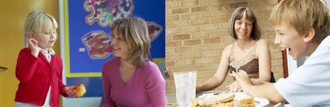
The Children’s Therapy team provides occupational therapy, speech and language therapy and physiotherapy for the children at St Luke’s. We are part of Northern Lincolnshire and Goole NHS Foundation Trust.

How do we work in school?
Once they get to St Luke’s some children do well without any therapy help at all – or with only a small amount. This is because they are in a school which meets their needs, has specialist teaching staff, and where they can learn and make progress.

But other children need help from one or more members of the therapy team in addition to the input from school staff. The amount of help they need may change from term to term and year to year.

We aim to provide a flexible service that is a resource for parents and staff – which gives children the right help at the right time, for as long as they need it.

We work in partnership with parents, school staff and any other professionals involved. We are not based at the school – but we visit regularly. Here are some of the ways that we work:
- We assess children’s needs – and monitor their progress
- We suggest goals and provide ideas and programmes of work for school staff and parents to use
- We offer training and advice to school staff in specialist areas
- We provide advice and support for parents – and may do home visits for some children
- We work with school staff on projects that will help all children

Occupational therapy

Our occupational therapy staff …

- Advise on how to help children become more independent e.g. at meal-times, dressing themselves
- Provide expertise on specialist equipment to support children with physical disabilities in all aspects of their life e.g. seating, hoists, splints
- Provide expertise in adapting children’s environments at home and at school to support their care and independence e.g getting up stairs, using the bathroom, participating in class.
- Give ideas for working on physical skills e.g. hand-writing, and meeting sensory
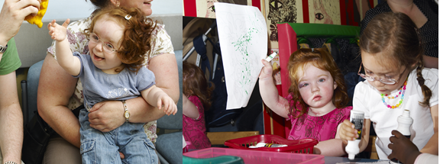
- needs e.g. over sensitivity to sound, textures or tastes

Speech and language therapy

Our speech and language therapy staff …
- Give advice to help children with eating and drinking needs
- Set up individual programmes to help children who need some focused work e.g. understanding what people say, early communication skills, speech sounds.
- Provide expertise on different and additional ways of communicating e.g. signs, symbols, communication bags, communication aids
- Work with school staff to make St Luke’s a ‘communication friendly’ place for all children – and create opportunities for communicating across the school day

Physiotherapy

Our physiotherapy staff …
- Advise on how to lift and handle children with physical disabilities – and how to use positioning to promote their health, wellbeing and access to learning
- Put individual programmes in place to help children with specific physical needs – or who need a burst of therapy to help them recover after surgery
- Advise on how to promote physical development, linking in with PE
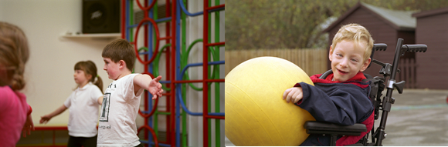
- Advise on the use of specialist equipment and techniques e.g. walkers, hydrotherapy

What to expect ….

If your child has been seeing a therapist before they start at the school, then information about them will be passed on to the therapist(s) in school. The therapist(s) in school will make contact with you to introduce themselves and discuss your child’s needs.

If your child has not been seeing a therapist (or therapists), this is probably because they do not need to – but you can discuss this further with school staff or with us if you have any concerns.

If we are seeing your child, we will keep in contact with you by…
- Letting you know at the start of each school year the name and contact details for the therapy staff your child sees – so it is easy to get in touch
- Using your child’s school diary to update you when we have had a session with your child – so you always know what’s happening
- Sending you copies of reports and programmes
- Inviting parents to a coffee morning once a term – so you have the chance to talk face to face
- Contributing to your child’s annual review meeting – if not in person, then through a written update and discussion beforehand.
- Sometimes offering home visits for children with the most complex needs
We want to work in partnership with you and provide you with any help and support that you need – as well as tap in to all your knowledge and expertise about your child!
Please don’t hesitate to give us a call or ask for a time to meet to discuss their goals, needs, progress, any issues or ideas for helping them.

Contact details for the team
We are based at:
Monarch House
Arkwright Way
Scunthorpe, DN16 1AL
Tel: 01724 203755 (Monday to Friday, 8.30am to 4.30pm)

The following staff visit St Luke’s School, although this will one of a number of different locations where they work.

Occupational Therapy staff
 | Work mobile | Working days (range of sites)
Jagpreet Singh | 07766 361572 | Mon- fri
Clare Seaton | - | Mon, Tues, Wed, Fri
Fiona Hawkridge | 07768 796786 | Mon, Wed, Thurs
Lynne Cowburn | 07766 085869 | Tues (pm)

Speech and language therapy staff
 | Work mobile | Working days (range of sites)
Emma Carter | 07920 711091 | Mon- fri
Jo Lawson | 07795 470705 | Mon- Fri
Emma Jones | 07890 253080 | Tues, Wed, Thurs

Physiotherapy staff
 | Work mobile | Working days (range of sites)
Karen Mayes | - | Tues
Anna Strong | - | Mon - Fri

Please note, because staff are out and about seeing children, they may not be able to get back to you straight away – but will get in touch as soon as possible.
For further information about Children’s Therapy Services – or other services provided by the Northern Lincolnshire and Goole NHS Trust, please visit:
www.nlg.nhs.net

